Title

SOP for Chrome Installation

Prepared By
Helpdesk

Date: Monday, 08-10- 2018

Version 2.0

Document History

Date | Author | Revision | Description
26-10-2010 | Team Lead Helpdesk | 1.0 | Document Creation
08-10-2018 | Team Lead Helpdesk | 2.0 | Company Name changed from TBSS to CBSL

Approved By: | Conneqt Business Solutions Limited
Manager-Technology | 2.0

Distribution List
Name | Department | Company | Rights
Manager-IT Support | Technology | CBSL | Review & Comment
Manager-Technology | Technology | CBSL | Modify
AVP Technology | Technology | CBSL | Review & Approve

Security Classification: CBSLRestricted.

- Open chrome_53.0.2785 set up file ”.exe”

2) Click on run

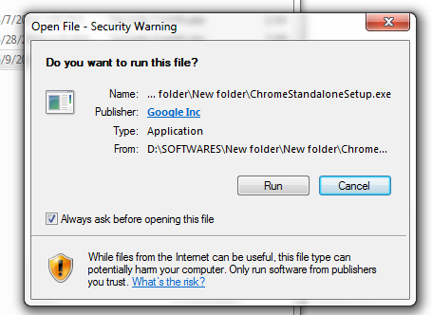

3) Installation start

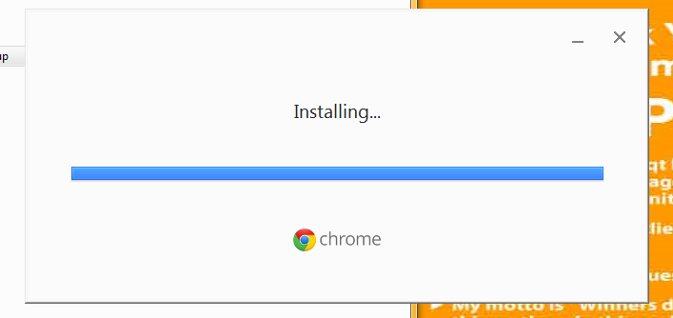

- 4) After installation complete, following windows show,

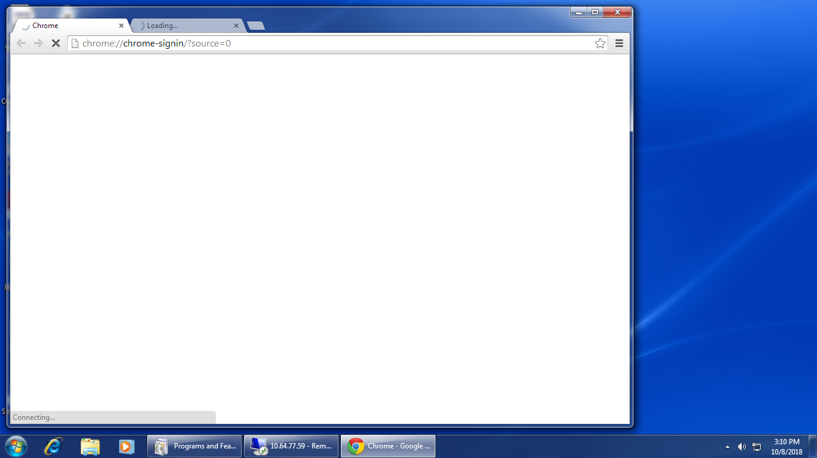

- Enter your ID & Password and login,
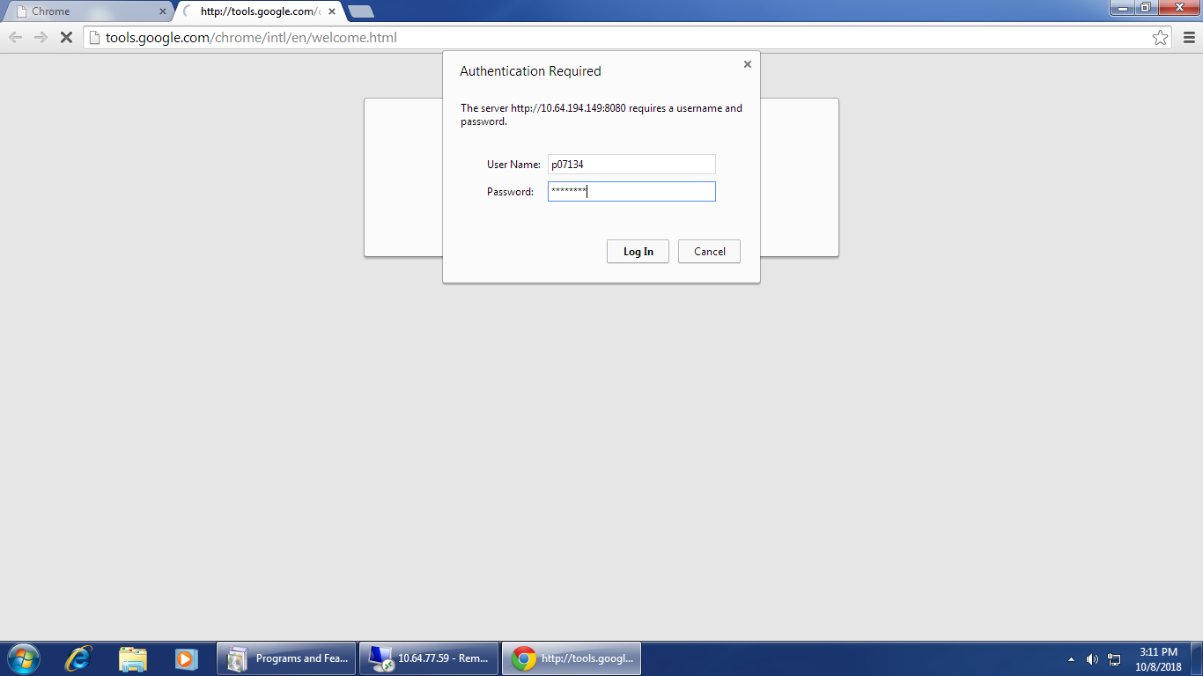

- Installation complete

